Portfolio Construction Basics
& Factor Models (CAPM / APT)
How Portfolios Are Built, and Why Returns Look the Way They Do
A Level 2 module in the Quantitative Finance Curriculum
Covers: equal weighting · minimum variance · maximum Sharpe · risk parity · long-only / long-short / market-neutral · CAPM (beta, alpha, SML) · APT · Fama-French factors (momentum, value, size, quality, low-volatility)

Table of Contents

How to Use This Guide
This document is a companion to Portfolio Construction Basics & Factor Models, the second-level module in the quantitative finance curriculum. It covers the standard frameworks for combining individual assets into a portfolio, and the standard frameworks for explaining why an asset earned the return it did, in terms of its exposure to systematic risk factors.
The module is self-contained: every construction method and every factor model is introduced from first principles, paired with a short runnable Python sketch, and illustrated with a chart wherever a picture makes the idea land faster than an equation. Read it start to finish if you are new to the topic, or jump straight to the section you need.

What you need to know before starting
- Returns & Portfolio Mathematics (Level 2, prerequisite module) — simple/log returns, portfolio variance wᵀΣw, and risk contribution are used throughout without re-derivation.
- Regression — ordinary least squares, R², and residuals. This is typically learned in parallel with this module, since CAPM and APT are both estimated by regression.
Tip: If regression is new to you, the intuition needed here is small: a factor model says 'this asset's return equals a constant, plus a sensitivity (beta) multiplied by a common factor, plus noise' — exactly the form of a simple linear regression, y = α + βx + ε.

Why it matters
Nearly all professional performance attribution and benchmark comparison is expressed in factor-model language. When a portfolio manager reports '2% of alpha and 8% of market beta', or a risk report says a book is 'factor-neutral', they are speaking directly in the vocabulary this module introduces. Without it, performance numbers are just numbers — with it, they become a story about where the return came from and whether it is repeatable.

How this connects to the rest of the curriculum
- Research — factor exposure is the standard lens for evaluating whether a 'new' signal is actually just a repackaged known factor. A signal that correlates highly with momentum or value is not really new, however novel its construction looks.
- Development — factor-model computation pipelines (rolling betas, factor exposures, factor-return histories) are standard research infrastructure, usually built once and reused across every strategy.
- Trading — beta-neutral and factor-neutral construction are common desk mandates: a trader may be free to take stock-specific risk but required to hedge out market or sector exposure.

Glossary of recurring terms
Equal weighting — Allocating the same fraction of capital to every asset in the portfolio, regardless of its risk or expected return.
Minimum-variance portfolio — The portfolio, among all achievable combinations of the available assets, with the lowest possible variance — found without needing any expected-return forecasts at all.
Maximum Sharpe / tangency portfolio — The portfolio that maximises expected excess return per unit of risk; geometrically, the point where a line from the risk-free rate is tangent to the efficient frontier.
Risk parity — A construction method that sizes positions so that every asset (or asset class) contributes equally to total portfolio risk, rather than equally to invested capital.
Long-only — A portfolio that holds only positive (long) positions, with no short-selling; net and gross exposure are equal.
Long-short — A portfolio that holds both long and short positions, typically with unequal magnitudes, resulting in gross exposure that exceeds net exposure.
Market-neutral — A long-short portfolio explicitly constructed so that net exposure to the market (or to a specified factor) is approximately zero.
CAPM (Capital Asset Pricing Model) — A single-factor model stating that an asset's expected excess return is proportional to its beta — its sensitivity to the market portfolio's excess return.
Beta (β) — The sensitivity of an asset's return to the return of a benchmark or factor, estimated as the slope of a regression of asset returns on factor returns.
Alpha (α) — The part of an asset's realised return that is not explained by its factor exposures — the regression intercept; a genuine, persistent alpha is what active managers claim to provide.
Security Market Line (SML) — The line, under CAPM, plotting expected return against beta for all assets; an asset above the line has positive alpha, below it has negative alpha.
APT (Arbitrage Pricing Theory) — A generalisation of CAPM allowing an asset's expected return to depend on sensitivities to multiple systematic factors, not just the market.
Fama-French factors — A family of empirically-motivated risk factors beyond the market, including size (SMB), value (HML), momentum (WML), quality (QMJ), and low-volatility (BAB), each built from a long-short portfolio sorted on the relevant characteristic.

Part 1 — Portfolio Construction Methods
This part covers the standard ways to turn a set of assets into a single portfolio, moving from the simplest possible rule (equal weighting) to methods that explicitly optimise for risk, return, or balanced risk contribution. All of them build directly on the return, variance, and risk-contribution mathematics introduced in the prerequisite module.

1.1 Equal Weighting
The simplest possible construction rule: allocate 1/N of capital to each of N assets, using no information at all about expected returns, volatilities, or correlations. Despite — or perhaps because of — its simplicity, equal weighting is a surprisingly strong benchmark: it requires no parameter estimation (and therefore no estimation error), it is trivially easy to rebalance, and empirical studies repeatedly find it hard for more sophisticated methods to beat out-of-sample, precisely because those methods must estimate inputs (expected returns especially) that are notoriously noisy.
w_i = 1 / N for all i
The weakness is equally simple: equal weighting takes no account of risk. If one asset is far more volatile than the others, it will dominate portfolio risk even though it receives the same capital allocation as everything else — exactly the pattern shown in Section 1.4's risk parity comparison.

1.2 Minimum-Variance Portfolios
The minimum-variance portfolio is the point on the achievable risk-return map with the lowest possible variance, found by solving a constrained optimisation problem that uses only the covariance matrix — no expected-return forecasts are required at all, which makes this portfolio comparatively robust to estimation error, since covariances are generally easier to estimate accurately than expected returns.
min_w wᵀ Σ w subject to Σw_i = 1 (and w_i ≥ 0 for long-only)
In the unconstrained (long-short allowed) case, this has a closed-form solution: w = Σ⁻¹1 / (1ᵀΣ⁻¹1), where 1* is a vector of ones. Adding a long-only constraint (w_i ≥ 0) removes the closed form and requires numerical quadratic programming, but is common in practice because institutional mandates frequently prohibit short-selling.

1.3 Maximum Sharpe Ratio (Tangency) Portfolio
Where the minimum-variance portfolio ignores expected returns entirely, the maximum-Sharpe (or tangency) portfolio explicitly maximises expected excess return per unit of risk. It answers the question: of all achievable portfolios, which one offers the best risk-adjusted reward?
max_w (wᵀμ − r_f) / √(wᵀΣw)
Geometrically, this is the point where a straight line drawn from the risk-free rate is tangent to the efficient frontier — the set of portfolios offering the highest expected return for each level of risk. That tangent line is the capital market line: combining the risk-free asset with the tangency portfolio in different proportions traces out every point on it, which is the foundation of the two-fund separation theorem underlying classical portfolio theory.
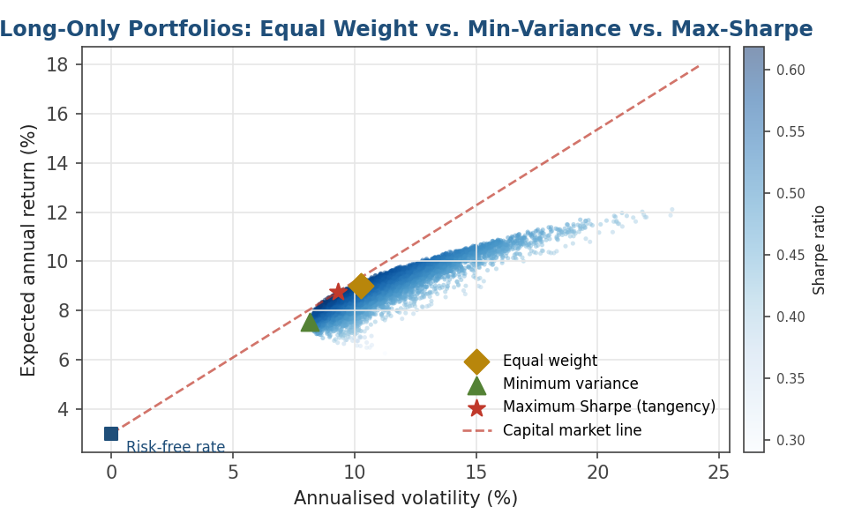
Figure 1.1 — A cloud of random long-only portfolios (colour-coded by Sharpe ratio) traces out the achievable region. Equal weight sits inside the cloud; the minimum-variance portfolio sits at its leftmost edge; the maximum-Sharpe (tangency) portfolio sits where the capital market line is tangent to the frontier.
Common mistake: Treating the maximum-Sharpe portfolio as if it were risk-free to identify in practice. It requires an expected-return forecast for every asset, and expected returns are estimated far less precisely than variances or covariances — small changes in the return forecast can move the tangency portfolio dramatically, a fragility often called 'error maximisation'.
import numpy as np
# mu: vector of expected returns, Sigma: covariance matrix, rf: risk-free rate
inv_Sigma = np.linalg.inv(Sigma)
ones = np.ones(len(mu))
# Minimum-variance weights (unconstrained, closed form)
w_minvar = inv_Sigma @ ones / (ones @ inv_Sigma @ ones)
# Maximum-Sharpe / tangency weights (unconstrained, closed form)
excess = mu - rf
w_tangency = inv_Sigma @ excess / (ones @ inv_Sigma @ excess)

1.4 Risk Parity
Risk parity sizes each position so that every asset contributes equally to total portfolio risk, using the risk-contribution decomposition RC_i = w_i · (Σw)_i / σ_p from the prerequisite module. In the simplified case where cross-asset correlations are ignored, this reduces to weighting inversely by volatility:
w_i ∝ 1 / σ_i (simplified, ignoring correlation)
The full risk-parity solution accounts for correlation as well as volatility, and generally requires numerical optimisation to find the weights at which every RC_i is exactly equal. The appeal of the approach is visible directly in the chart below: an equally-weighted mix of equities, bonds, and commodities looks balanced in capital terms, but because equities and commodities are far more volatile than bonds, they end up dominating total portfolio risk. Risk parity corrects this by underweighting the volatile assets and overweighting the stable ones.
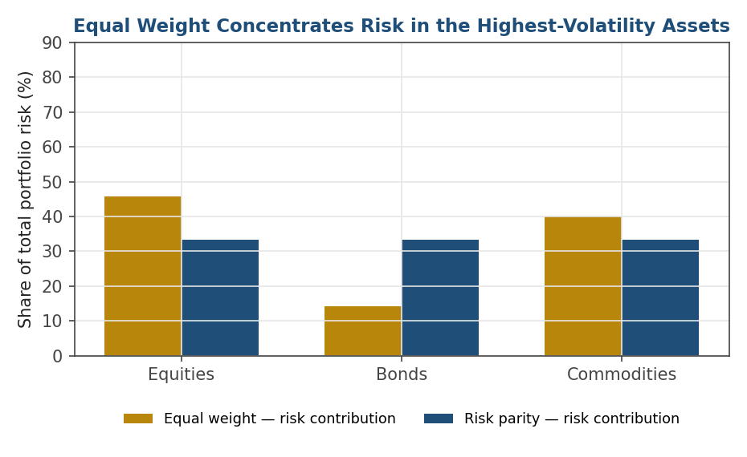
Figure 1.2 — Under equal weighting, the higher-volatility asset classes (equities and commodities) supply most of total portfolio risk despite equal capital allocation. Risk parity rebalances weights so each asset class contributes an equal share.
Tip: Risk parity says nothing about expected returns — like minimum variance, it is a risk-only construction. In practice, risk-parity portfolios are often leveraged up (borrowing to scale exposure) to bring overall portfolio volatility back up to a target level, since naive risk parity tends to be bond-heavy and therefore lower-return than an equity-heavy alternative.

1.5 Long-Only, Long-Short, and Market-Neutral Construction
Beyond how weights are sized, portfolios differ in whether they are allowed to hold negative (short) positions, and if so, how those short positions are used. Three conventions cover most real-world mandates:
- Long-only — every position is positive; net exposure equals gross exposure. This is the default for most mutual funds and long-only institutional mandates, largely for regulatory and operational reasons (shorting requires borrowing the security, posting collateral, and accepting theoretically unlimited loss).
- Long-short — the portfolio holds both long and short positions, usually with more long than short exposure, so that gross exposure (the sum of the absolute values of all positions) exceeds net exposure (the simple sum, long minus short).
- Market-neutral — a long-short portfolio explicitly constructed so that net exposure to the market is approximately zero, typically by matching long and short dollar exposure or, more precisely, matching long and short beta-weighted exposure.
Net exposure = Σ(long positions) + Σ(short positions) Gross exposure = Σ|long positions| + Σ|short positions|
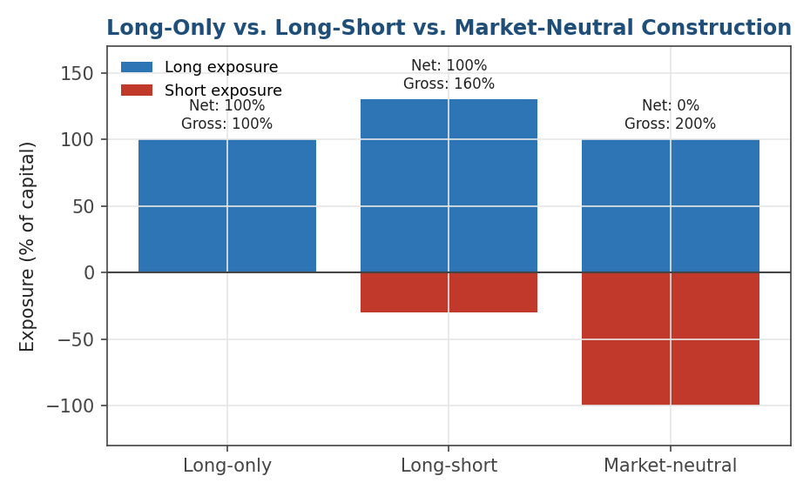
Figure 1.3 — Net exposure is what remains after longs and shorts offset; gross exposure is the total capital at risk, regardless of direction. A market-neutral book can carry 200% gross exposure while running approximately 0% net.
Why this distinction matters: Two portfolios with identical net exposure can carry very different amounts of actual risk if their gross exposure differs — a market-neutral book with 200% gross exposure is making twice as many bets (long and short) as a long-only book with 100% gross exposure, even though both may show zero or full net market exposure respectively. Risk reports track both numbers for exactly this reason.

Part 2 — Factor Models: CAPM, APT, and Style Factors
Having covered how to combine assets into a portfolio, this part turns to a different question: why does an asset earn the return it does? Factor models answer this by decomposing realised or expected returns into compensation for exposure to systematic, non-diversifiable risks — the same systematic risk that Section 1.7 of the prerequisite module showed cannot be diversified away no matter how many assets are added to a portfolio.

2.1 CAPM: Beta, Alpha, and the Security Market Line
The Capital Asset Pricing Model (CAPM) is the original and simplest factor model. It states that an asset's expected excess return (over the risk-free rate) is proportional to a single number, its beta — the asset's sensitivity to the return of the overall market portfolio:
E[R_i] − r_f = β_i · (E[R_m] − r_f)
Beta is estimated empirically by regressing an asset's excess returns on the market's excess returns; the slope of that regression line is β, and the intercept is alpha — the part of the asset's average return left unexplained by its market exposure:
R_i − r_f = α_i + β_i (R_m − r_f) + ε_i
Plotting expected return against beta for every asset traces out the Security Market Line (SML). Under CAPM, every asset should sit exactly on this line; in practice, realised returns scatter around it, and the vertical distance between an asset's actual return and the line is precisely its alpha — positive above the line, negative below it.
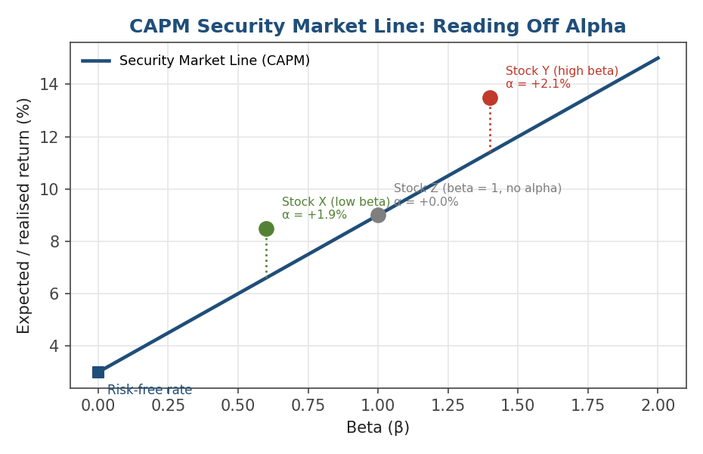
Figure 2.1 — The Security Market Line plots expected return against beta. A stock's realised alpha is the vertical gap between its actual return and the line's prediction for its beta — genuinely 'extra' return not explained by market exposure alone.
Worked example. With a risk-free rate of 3% and an expected market return of 9%, CAPM predicts a stock with beta 1.4 should earn 3% + 1.4 × (9% − 3%) = 11.4%. If that stock actually returned 13.5%, its alpha is 13.5% − 11.4% = +2.1% — a genuinely unexplained excess return, exactly as shown for 'Stock Y' in the chart above.
Common mistake: Interpreting CAPM beta as a complete risk model rather than a single, limited factor. Two stocks can have identical betas to the market and completely different risk profiles — one heavily exposed to interest-rate risk, the other to commodity prices — that CAPM's single factor cannot distinguish. Beta describes market sensitivity, not total risk.
import numpy as np
excess_stock = stock_returns - rf_returns
excess_market = market_returns - rf_returns
# beta and alpha via simple linear regression (least squares)
beta, alpha = np.polyfit(excess_market, excess_stock, deg=1)
predicted = alpha + beta * excess_market
residuals = excess_stock - predicted # idiosyncratic, stock-specific risk

2.2 Arbitrage Pricing Theory (APT)
Arbitrage Pricing Theory generalises CAPM's single market factor into any number of systematic factors, without requiring the strong theoretical assumptions (a single, mean-variance-efficient market portfolio) that underpin CAPM. APT simply asserts that an asset's expected return is a linear function of its sensitivities (betas, or 'loadings') to K systematic factors:
E[R_i] − r_f = β_{i,1} F_1 + β_{i,2} F_2 + ... + β_{i,K} F_K
APT does not specify what the factors are — that is an empirical question, answered differently by different modelling traditions (macroeconomic variables, statistically-extracted principal components, or empirically-motivated style factors, covered next). What APT contributes is the logical structure: multiple sources of systematic risk, each priced separately, with the asset's total expected compensation being the sum of its exposure to each.
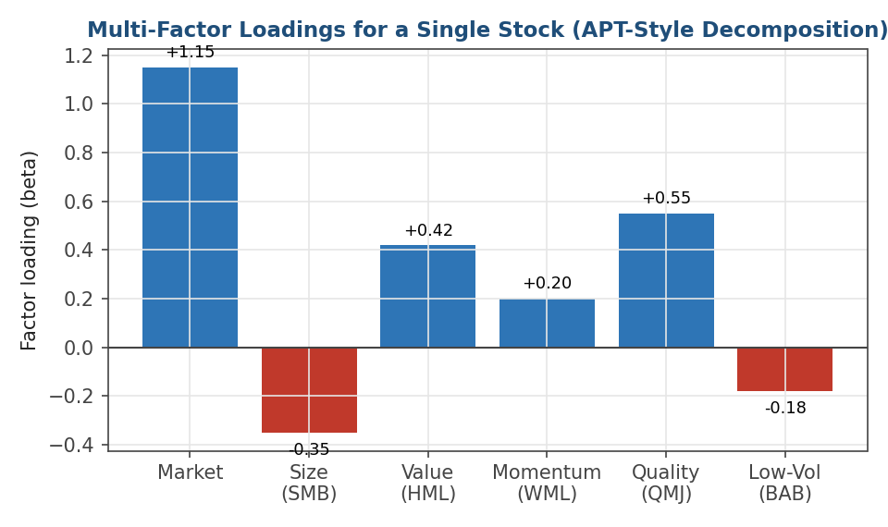
Figure 2.2 — A single stock's estimated loadings on six systematic factors. Positive loadings mean the stock behaves like a long position in that factor; negative loadings mean it behaves like a short position.
Reading the chart above: this hypothetical stock has a market beta above 1 (more volatile than the market), a negative size loading (behaves more like a large-cap stock), positive value and quality loadings (tilts toward cheaper, higher-quality companies), mild positive momentum, and a negative low-volatility loading (does not behave like a defensive, low-vol stock). Each of these loadings is estimated exactly the way CAPM's single beta is — by regression — just with several factors on the right-hand side simultaneously.

2.3 Fama-French and Beyond: The Standard Style Factors
The most widely used concrete implementation of APT's multi-factor structure is the family of factors popularised by Fama and French and extended by later researchers. Each factor is constructed as a long-short portfolio sorted on a specific company characteristic, on the theory that the long-short spread captures a systematic risk premium (or, in some interpretations, a persistent behavioural or structural anomaly).
Factor | Sorted on | Long-short construction
Size (SMB) | Market capitalisation | Long small-cap, short large-cap ('small minus big')
Value (HML) | Book-to-market ratio | Long cheap (high book/market), short expensive ('high minus low')
Momentum (WML) | Trailing 6–12 month return | Long recent winners, short recent losers ('winners minus losers')
Quality (QMJ) | Profitability, stability, growth | Long high-quality, short low-quality ('quality minus junk')
Low-volatility (BAB) | Historical volatility / beta | Long low-beta, short high-beta, leveraged to match market beta ('betting against beta')

A three-factor model (market, size, value) was Fama and French's original 1992 specification; momentum, quality, and low-volatility were added by later research as further systematic patterns in average returns were identified that the original three factors could not explain. Each new factor addition is itself a small case study in the APT logic: find a characteristic that predicts a return spread, show that spread is not explained by existing factors, and it earns a place in the model.
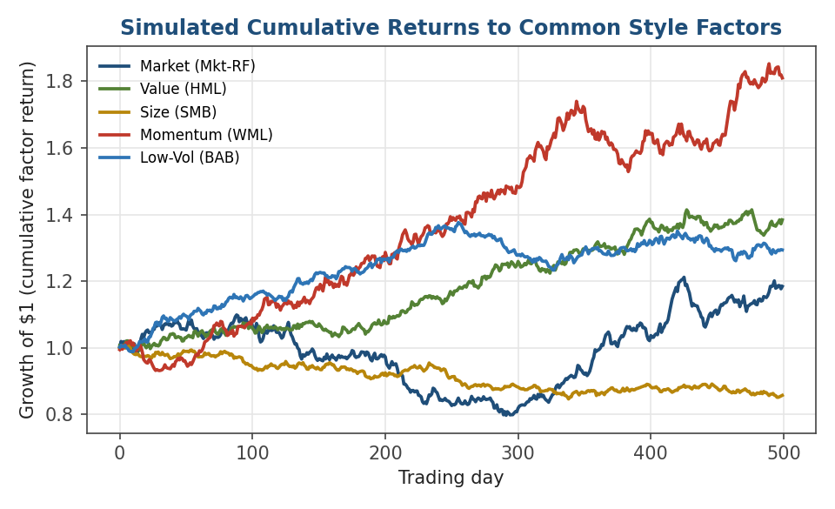
Figure 2.3 — Simulated cumulative returns to the market factor and four common style factors. Each factor has its own risk-return profile and can go through extended periods of underperformance, exactly like an individual asset.
Tip: Style factors are not 'free money' — each one carries its own risk, its own long stretches of underperformance (value famously underperformed growth for most of the 2010s), and its own crowding risk if too much capital chases the same factor at once. They are additional systematic risks to be compensated for, not arbitrage opportunities.

2.4 Putting It Together: Decomposing a Realised Return
The practical payoff of a multi-factor model is being able to take a single stock's realised return over some period and split it into the pieces contributed by each systematic factor exposure, plus whatever is left over as alpha. This is exactly the practical exercise at the end of this module: running a Fama-French regression and decomposing the result.
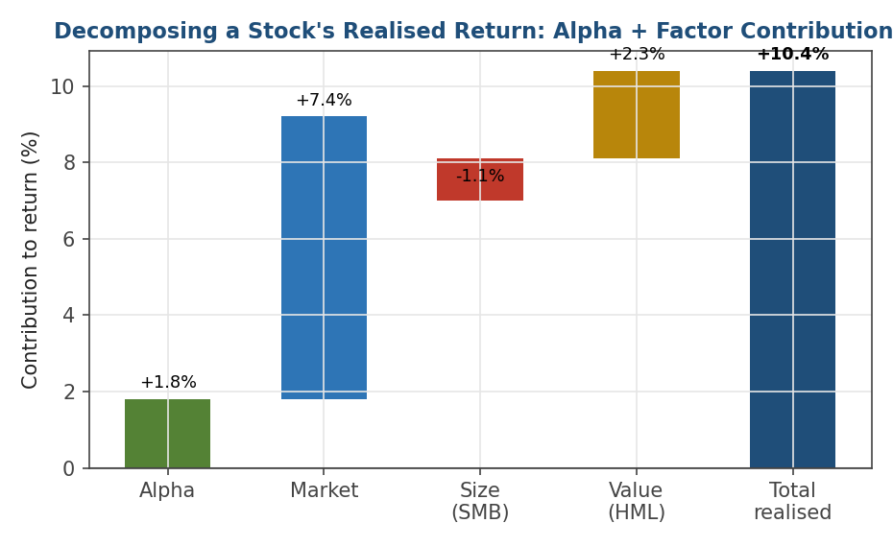
Figure 2.4 — A stock's 10.4% realised return decomposed via a 3-factor regression: 7.4 percentage points from market exposure, −1.1 from a negative size loading (the stock behaved like a large-cap during a period when small-caps outperformed), 2.3 from value exposure, and 1.8 points of alpha left unexplained by any of the three factors.
Notice that alpha here is small relative to the factor contributions — this is typical. For most stocks and most periods, the great majority of realised return is explained by systematic factor exposure, not stock-specific skill or mispricing. This is precisely why performance attribution insists on decomposing returns this way: a manager who reports '10.4% return' sounds skilled, but a manager who reports '1.8% alpha after controlling for market, size, and value exposure' is making a much more modest, and much more verifiable, claim.

Practical Exercise
Using a single stock's daily or monthly returns over at least three years, alongside the Fama-French 3-factor data (market, size, value — publicly available from Kenneth French's data library):
- Compute the stock's excess returns (return minus the risk-free rate) for each period.
- Run an ordinary least squares regression of the stock's excess returns on the three factor returns (market, SMB, HML).
- Record the estimated alpha and the three factor betas, along with the regression R² — how much of the stock's return variance is explained by the three factors versus left as idiosyncratic residual?
- Multiply each estimated beta by the average factor return over the period to get each factor's average contribution to the stock's return, and compare the sum of alpha plus factor contributions against the stock's actual average return (they should match closely, per Figure 2.4).
- Repeat the regression using only the single market factor (i.e. plain CAPM) and compare the alpha estimate — does it change once size and value are controlled for? This is the essence of the common mistake covered below.
import statsmodels.api as sm
X = factor_data[['Mkt-RF', 'SMB', 'HML']]
X = sm.add_constant(X) # adds the alpha (intercept) term
y = stock_excess_returns
model = sm.OLS(y, X).fit()
alpha = model.params['const']
betas = model.params[['Mkt-RF', 'SMB', 'HML']]
r_squared = model.rsquared

Common Beginner Mistakes
Mistake 1 — Beta as a complete risk model: Interpreting CAPM beta as a complete description of an asset's risk rather than a single, limited factor. Two assets with identical betas can have very different exposures to interest rates, sector shocks, or idiosyncratic risk that a single-factor model cannot capture — this is exactly the gap that APT and multi-factor models were built to close.
Mistake 2 — Claiming alpha without controlling for known factors: Reporting a positive 'alpha' from a single-factor (CAPM) regression when a large part of that apparent alpha is actually compensation for exposure to well-known factors like value or momentum that were never controlled for. A genuine, defensible alpha claim must survive controlling for every systematic factor a sophisticated allocator would already expect exposure to.
Mistake 3 — Confusing net and gross exposure: Describing a long-short book purely by its net exposure (e.g. 'market-neutral') without also reporting gross exposure. A book can be net-neutral while running very high gross exposure, and therefore carrying much more risk than 'neutral' suggests.

Advanced Extensions
Once this module is comfortable, the natural next steps (Level 3) branch in three directions. Multi-factor risk models extend the Fama-French style factors into commercial-grade risk models (e.g. Barra-style) with dozens of industry and style factors used for risk decomposition at scale. Statistical factor models flip the approach around: rather than pre-specifying factors like value or momentum, they extract factors directly from the data using techniques like Principal Component Analysis (PCA), letting the data reveal whatever systematic sources of co-movement are actually present — at the cost of the factors being harder to interpret economically. Factor-neutral optimisation builds directly on Part 1's construction methods, adding explicit constraints that portfolio-level exposure to specified factors (market, size, value, etc.) be held at or near zero, so that any resulting return can be attributed to stock selection rather than factor timing.

Professional Applications
- Performance attribution — splitting a fund's realised return into alpha and factor contributions, the standard language used to evaluate whether a manager's results reflect skill or simply exposure to well-compensated systematic risks.
- Factor-neutral portfolio construction — building portfolios that deliberately avoid unwanted exposure to specific factors, so that risk and return can be attributed cleanly to the intended source (e.g. a stock-picking strategy that hedges out market and sector beta).
- Benchmark-relative risk reporting — describing a portfolio's risk not just in absolute terms but relative to a benchmark's factor exposures, which is how most institutional risk reports and mandates are actually framed.

Where to Go Next
This module gives you both halves of professional portfolio management's core vocabulary: how portfolios are built (equal weight, minimum variance, maximum Sharpe, risk parity, and the long/short exposure conventions), and how returns are explained (CAPM, APT, and the standard style factors). Nearly everything that follows in the curriculum — performance evaluation, risk management, and strategy design — will use this vocabulary without re-deriving it.

Suggested paths depending on your focus
- Heading into research: move on to factor-neutral signal evaluation — testing whether a new signal survives after controlling for the Fama-French factors covered in Section 2.3, which builds directly on the practical exercise above.
- Heading into risk management: go to Level 3's multi-factor and statistical (PCA-based) risk models, which scale Section 2.2's APT framework into production-grade risk decomposition.
- Heading into trading: focus on Sections 1.5 and 2.4 — beta-neutral and factor-neutral construction, and clean return decomposition, are exactly what desk mandates typically require.

